

Description

IntendedUsers

Features

User Interface Mocks

Screen 1

Screen 2

Screen 3

Key Considerations

How will your app handle data persistence?

Describe any edge or corner cases in the UX.

Describe any libraries you’ll be using and share your reasoning for including them.

Describe how you will implement Google Play Services or other external services.

Next Steps: Required Tasks

Task 1: Project Setup

Task 2: Rest API

Task 3: Data persistence app

Task 4: Handle authentication

Task 4: Post data to api

**GitHub Username**: abdullah10182

**Aruba Flora & Fauna**

# Description

The app is intended as an educational tool to help the user learn more about the diverse nature of the island of Aruba. Aruba is a pretty small island and it is therefore difficult to find information about the flora and fauna of the island on the internet.

The app will consist of two main categories for now, namely plants (flora) and animals (fauna).

Under each category the users can select species of plants or animals to find out more information.

The idea is that in the future along with the app there will be also a website that displays all this information. The website will initially be build but only as a rest server to feed and collect data to and from the app.

# **Intended User**s

* Nature enthusiasts
* Scientists
* Students
* Tourists
* Kids

# Features

* View info about a species
* View the local name of the species
* See if the species is endemic or invasive to the island
* User can create account and send corrections, questions or feedback on a species or request to add a species
* App will not need RTL support because it will only be English and is mostly intended for people from Aruba
* All strings will be stored in xml files in their corresponding folders

**Nice to have**

* Image classification of plants
* Geo tag where the image of the plant was taken

# Technologies

* Programming language: Native Android app written in Java
* IDE: Android Studio
* Rest API: Drupal 8.x.x as headless CMS
* Gradle 6.x.x
* Retrofit 2.6.x
* Glide 4.10.x
* Butterknife 10.2.x
* Material design 28.x.x

# User Interface Mocks

## Screen 1

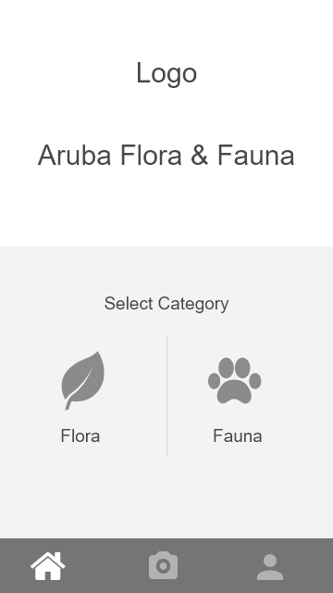

## Screen 2

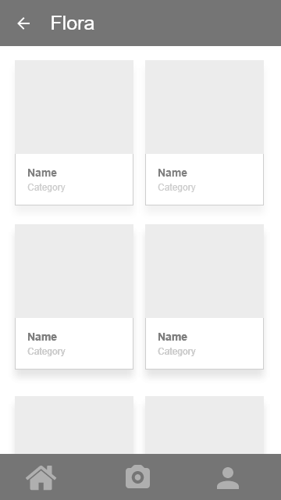

## Screen 3

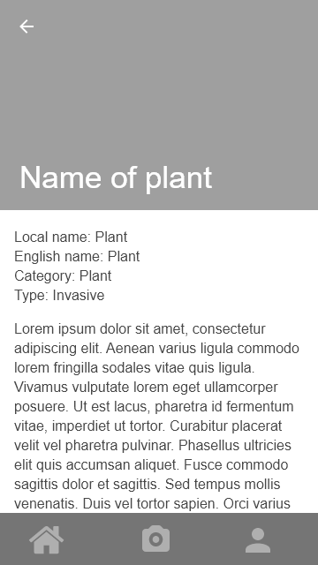

Screen 4 (widget)

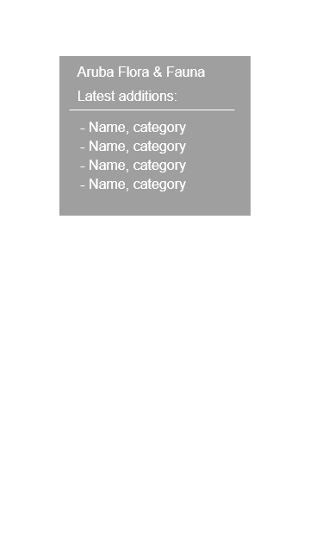

# Key Considerations

### How will your app handle data persistence?

I will use Drupal as a headless CMS as a rest API. And for the app I will use room to persist visited data.

### Describe any edge or corner cases in the UX.

The app will only work in portrait mode.

### Describe any libraries you’ll be using and share your reasoning for including them.

Retrofit to get and post data. Glide to handle images and the material design library for the design. These are mainly what I used in the course, so I already have experience with these.

### Describe how you will implement Google Play Services or other external services.

Will use try to use google maps to geo tag where image was taken.

# Next Steps: Required Tasks

This is the section where you can take the main features of your app (declared above) and break them down into tangible technical tasks that you can complete one at a time until you have a finished app.

## Task 1: Project Setup

* Start blank project in AS
* Import all needed libraries
* Create all activities and fragments

## Task 2: Rest API

* Set up drupal as headless cms
* Create all fields
* Set up rest server

## Task 3: Data persistence app

* Set up room
* Connect to api
* Display data

## Task 4: Handle authentication

* Create user registration form and make it work through either a webview or through an api with JWT
* Create user sign up form and make it work with api with JWT
* All calls must me authorized with JWT
* Try to implement SSO with Google and Facebook login

## Task 4: Post data to api

* Create user upload suggestions or feedback form
* Create camera activity
* Post picture to api